**8.10 Check Box in Java** :-

The Checkbox class is used to create a checkbox. It is used to turn an option on (true) or off (false). Clicking on a Checkbox changes its state from "on" to "off" or from "off" to "on".

**public** **class** Checkbox **extends** Component **implements** ItemSelectable, Accessible

**import** java.awt.*;

**public** **class** CheckboxExample

{

     CheckboxExample(){

       Frame f= **new** Frame("Checkbox Example");

        Checkbox checkbox1 = **new** Checkbox("C++");

        checkbox1.setBounds(100,100, 50,50);

        Checkbox checkbox2 = **new** Checkbox("Java", **true**);

        checkbox2.setBounds(100,150, 50,50);

        f.add(checkbox1);

        f.add(checkbox2);

        f.setSize(400,400);

        f.setLayout(**null**);

        f.setVisible(**true**);

     }

**public** **static** **void** main(String args[])

{

**new** CheckboxExample();

}

}

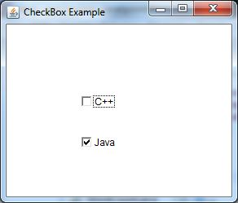

This section illustrates you how to create a Check Box component in Java Swing.

In this section, you can learn simply creating the Check Box in Java Swing. Check Boxes are created in swing by creating the instance of the **JCheckBox** class using it's constructor which contains the string which has to be shown beside the check box on the frame or window like this:

This is written like:

**JCheckBox** chk = new **JCheckBox**("This is the Check Box");

This component of the *javax.swing.*;* is added to the frame using the add(component) method of the **JFrame** class.

**Here is the code of the program:**

|  |
| --- |
| **import**javax.swing.*;  **public class**CreateCheckBox{   **public static void**main(String[] args){   JFrame frame = **new**JFrame("Check Box Frame");   JCheckBox chk = **new**JCheckBox("This is the Check Box");   frame.add(chk);   frame.setSize(400, 400);   frame.setDefaultCloseOperation(JFrame.EXIT_ON_CLOSE);   frame.setVisible(**true**);   } } |